**Name & ID**:\_\_\_\_\_\_\_\_\_\_\_\_\_\_\_\_Basil khowaja\_\_bk08432\_\_\_\_\_\_\_\_\_\_\_\_ **Date:** 19 nov 24

|  |
| --- |
| **EE-424L Data Communication & Networking**  **Fall 2024**  **Habib University**  **Dhanani School of Science & Engineering** |

LAB 11: Subnetting

|  |  |  |  |  |  |  |  |  |  |  |  |  |  |  |  |  |  |  |  |  |  |  |  |  |  |
| --- | --- | --- | --- | --- | --- | --- | --- | --- | --- | --- | --- | --- | --- | --- | --- | --- | --- | --- | --- | --- | --- | --- | --- | --- | --- |
| **Lab #11 Marks distribution:**   |  |  |  |  |  |  |  | | --- | --- | --- | --- | --- | --- | --- | |  |  | **LR2=10** | **LR4=15** | **LR5=15** | **AR2=05** | **AR4=05** | | **In-Lab Tasks** | **Task 1** |  | /05 | /05 | /05 | /05 | | **Task 2** | /10 | /10 | /10 | | **Marks Obt.** | **/50** | | | | | | |

|  |  |
| --- | --- |
| o**bjectives** | **The objective of this Lab is to design an IP Addressing Scheme using subnetting and Assign IP Addresses to Network Devices and Verify Connectivity** |

|  |  |  |
| --- | --- | --- |
| **Task 1:** |  | |
|  | |  |

**Exercise 1:**

Now that you have an understanding of subnetting, put this knowledge to use. In this task, you are given two address / mask combinations, written with the prefix/length notation, which have been assigned to two devices. Your task is to determine if these devices are on the same subnet or different subnets. You can use the address and mask of each device in order to determine to which subnet each address belongs to.

**Device A: 172.16.17.30/20**

**Device B: 172.16.28.15/20**

**Determine the Subnet for Device A:**

|  |
| --- |
| C:\Users\Dell\AppData\Local\Packages\5319275A.WhatsAppDesktop_cv1g1gvanyjgm\TempState\8371D58A2140475594CB7A1C22F0BAAA\WhatsApp Image 2024-11-19 at 09.09.16_68222dc3.jpg |

**Determine the Subnet for Device B:**

|  |
| --- |
| C:\Users\Dell\AppData\Local\Packages\5319275A.WhatsAppDesktop_cv1g1gvanyjgm\TempState\77EBEF784ECDB4CE5591340311ADB2E9\WhatsApp Image 2024-11-19 at 09.09.31_d8034858.jpg |

**Exercise 2:**

Given the Class C network of 204.15.5.0/24, subnet the network in order to create the network in [Figure 1](https://www.cisco.com/c/en/us/support/docs/ip/routing-information-protocol-rip/13788-3.html#figthree) with the host requirements shown.

**Figure 1**

[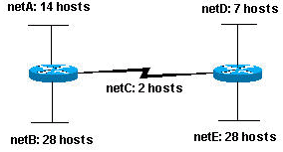](https://www.cisco.com/c/dam/en/us/support/docs/ip/routing-information-protocol-rip/13788-3-02.gif)

Looking at the network shown in [Figure 1](https://www.cisco.com/c/en/us/support/docs/ip/routing-information-protocol-rip/13788-3.html#figthree), How many subnets are needed? \_\_\_5\_\_\_\_\_\_\_

Is this possible with a Class C network? And if so, then how and assign subnets to topology in Fig. 1 as well **using VLSM**.

|  |
| --- |
| **NetA**  * **Subnet Address:** 204.15.5.64/28 * **Prefix:** /28 * **Host Range:** 204.15.5.65 – 204.15.5.78 * **Broadcast Address:** 204.15.5.79  **NetB**  * **Subnet Address:** 204.15.5.0/27 * **Prefix:** /27 * **Host Range:** 204.15.5.1 – 204.15.5.30 * **Broadcast Address:** 204.15.5.31  **NetC**  * **Subnet Address:** 204.15.5.88/30 * **Prefix:** /30 * **Host Range:** 204.15.5.89 – 204.15.5.90 * **Broadcast Address:** 204.15.5.91  **NetD**  * **Subnet Address:** 204.15.5.80/29 * **Prefix:** /29 * **Host Range:** 204.15.5.81 – 204.15.5.86 * **Broadcast Address:** 204.15.5.87  **NetE**  * **Subnet Address:** 204.15.5.32/27 * **Prefix:** /27 * **Host Range:** 204.15.5.33 – 204.15.5.62 * **Broadcast Address:** 204.15.5.63 |

|  |  |
| --- | --- |
| **Task 2: Design and verify connectivity** |  |

## C:\Users\Allan\Desktop\Sandbox\development\Griffin\en\1.0\Activities\PT\NetworkFund\Chapter-08\8.1.3.7_Subnetting_Scenario_2\8.1.3.7_Subneting_Scenario_2_Topology.png**Topology**

**Scenario**

In this task, you are given the network address of 172.31.1.0 /24 to subnet and provide the IP addressing for the network shown in the Topology. The required host addresses for each WAN and LAN link are labeled in the topology.

Note: you can use normal or serial cable to make connection from router to router.

**Part 1: Design an IP Addressing Scheme**

**Step 1: Subnet the 172.31.1.0/24 network based on the maximum number of hosts required by the largest subnet.**

1. Based on the topology, how many subnets are needed? \_\_\_7\_\_\_\_\_\_\_\_\_\_\_\_
2. How many bits must be borrowed to support the number of subnets in the topology table? \_\_\_\_\_3\_\_\_
3. How many subnets does this create? \_8\_\_\_\_\_\_\_\_\_\_\_\_\_\_
4. How many usable host addresses does this create per subnet? \_\_\_\_\_\_\_\_\_\_\_\_\_30\_\_\_\_\_\_\_\_\_
5. Calculate the binary value for the first five subnets. Subnet zero is already shown.

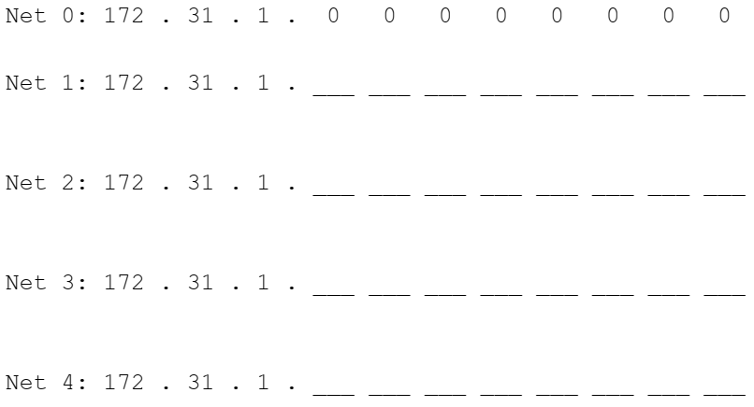

Net1: 172.31.1.32 10101100.00011111.00000001.00100000

Net2: 172.31.1.64 10101100.00011111.00000001.01000000

Net3: 172.31.1.96 10101100.00011111.00000001.01100000

Net4: 172.31.1.128 10101100.00011111.00000001.10000000

1. Calculate the binary and decimal value of the new subnet mask.

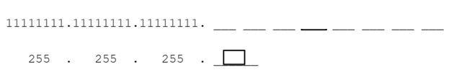

11111111.11111111.11111111.11100000

255.255.255.224

1. Complete the Subnet Table, listing all available subnets, the first and last usable host address, and the broadcast address. The first subnet is done for you. Repeat until all addresses are listed.

Note: You may not need to use all rows.

**Subnet Table:**

|  |  |  |  |  |
| --- | --- | --- | --- | --- |
| **Subnet Number** | **Subnet IP** | **First Usable Host IP** | **Last Usable Host IP** | **Broadcast Address** |
| **0** | **172.31.1.0** | **172.31.1.1** | **172.31.1.14** | **172.31.1.15** |
| **1** | 172.31.1.32 | 172.31.1.33 | 172.31.1.46 | 172.31.1.47 |
| **2** | 172.31.1.64 | 172.31.1.65 | 172.31.1.78 | 172.31.1.79 |
| **3** | 172.31.1.96 | |  | | --- | | 172.31.1.97 |  |  | | --- | |  | | 172.31.1.110 | 172.31.1.111 |
| **4** | 172.31.1.128 | 172.31.1.129 | 172.31.1.142 | 172.31.1.143 |
| **5** | 172.31.1.160 | 172.31.1.161 | 172.31.1.174 | 172.31.1.175 |
| **6** | 172.31.1.192 | 172.31.1.193 | 172.31.1.206 | 172.31.1.207 |
| **7** | 172.31.1.224 | 172.31.1.225 | 172.31.1.238 | 172.31.1.239 |
| **8** |  |  |  |  |

**Step 2: Assign the subnets to the network shown in the topology.**

**When assigning the subnets, keep in mind that routing is necessary to allow information to be sent throughout the network.**

1. Assign Subnet 0 to the R1 LAN: 172.31.1.1 – 172.31.1.14
2. Assign Subnet 1 to the R2 LAN: 172.31.1.33 – 172.31.1.46
3. Assign Subnet 2 to the R3 LAN: 172.31.1.65 – 172.31.1.78
4. Assign Subnet 3 to the R4 LAN: 172.31.1.97 – 172.31.1.110
5. Assign Subnet 4 to the link between R1 and R2. 172.31.1.129 –172.31.1.130
6. Assign Subnet 5 to the link between R2 and R3. 172.31.1.161—172.31.1.162
7. Assign Subnet 6 to the link between R3 and R4. 172.31.1.193—173.31.1.194

**Step 3: Document the addressing scheme.**

Assign the first usable IP addresses to routers interfaces for each of the links.

Use the following method to assign WAN link IP addresses:

* + For the WAN link between R1 and R2, assign and mention the first usable IP address to R1 and last usable IP address to R2.

|  |
| --- |
| 172.31.1.129-R1  172.31.1.130-R2 |

* + For the WAN link between R2 and R3, assign and mention the first usable IP address to R2 and last usable IP address to R3.

|  |
| --- |
| 172.31.1.161-R2  172.31.1.162-R3 |

* + For the WAN link between R3 and R4, assign and mention the first usable IP address to R3 and last usable IP address to R4.

|  |
| --- |
| 172.31.1.193-R3  172.31.1.194-R4 |

Assign the last usable IP addresses to the hosts.

**Part 2: Assign IP Addresses to Network Devices and Verify Connectivity**

Most of the IP addressing is already configured on this network. Implement the following steps to complete the addressing configuration.

Step 1: Configure IP addressing on R1 and R2 LAN interfaces, on S3 and PC4, including the default gateway.

Step 2: Configure Static or Dynamic Routing (RIP version 2 supports subnetting) on R1, R2, R3 and R4.

RIP Ver-2 syntax is below:

*R(config)#router rip*

*R(config-router)#version 2*

*R(config-router)#network 1.2.3.4*

*R(config-router)#end*

Step 3: Verify connectivity.

You can only verify connectivity from R1, R2, S3, and PC4. However, you should be able to ping every IP address listed in the Addressing Table. Check this to RA.

|  |
| --- |
| Checked by miss zareen |

**Attach the Network Topology, all configurations and verification results with the Lab manual.**

**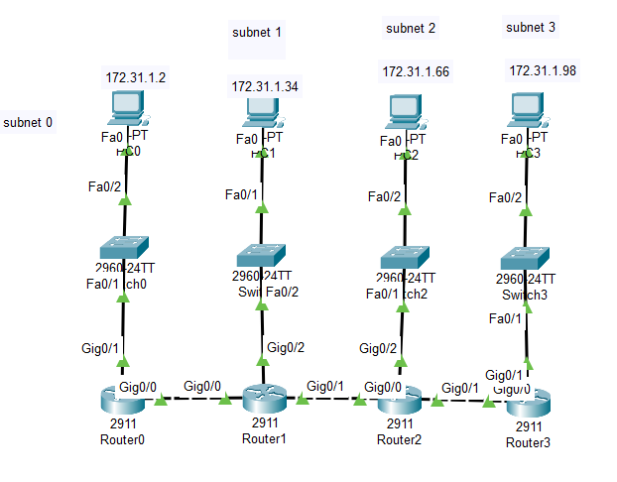**

**Lab Evaluation Assessment Rubric**

**EE-424 Lab 11**

|  |  |  |  |  |  |
| --- | --- | --- | --- | --- | --- |
| **#** | **Assessment Elements** | **Level 1: Unsatisfactory**  **Points 0-1** | **Level 2: Developing**  **Points 2** | **Level 3: Good**  **Points 3** | **Level 4: Exemplary**  **Points 4** |
| **LR2** | **Program/Code/ Simulation Model/ Network Model** | Program/code/simulation model/network model does not implement the required functionality and has several errors. The student is not able to utilize even the basic tools of the software. | Program/code/simulation model/network model has some errors and does not produce completely accurate results. Student has limited command on the basic tools of the software. | Program/code/simulation model/network model gives correct output but not efficiently implemented or implemented by computationally complex routine. | Program/code/simulation /network model is efficiently implemented and gives correct output. Student has full command on the basic tools of the software. |
| **LR4** | **Data Collection** | Measurements are incomplete, inaccurate and imprecise. Observations are incomplete or not included. Symbols, units and significant figures are not included. | Measurements are somewhat inaccurate and imprecise. Observations are incomplete or vague. Major errors are there in using symbols, units and significant digits. | Measurements are mostly accurate. Observations are generally complete. Minor errors are present in using symbols, units and significant digits. | Measurements are both accurate and precise. Data collection is systematic. Observations are very thorough and include appropriate symbols, units and significant digits and task completed in due time. |
| **LR5** | **Results & Plots** | Figures/ graphs / tables are not developed or are poorly constructed with erroneous results. Titles, captions, units are not mentioned. Data is presented in an obscure manner. | Figures, graphs and tables are drawn but contain errors. Titles, captions, units are not accurate. Data presentation is not too clear. | All figures, graphs, tables are correctly drawn but contain minor errors or some of the details are missing. | Figures / graphs / tables are correctly drawn and appropriate titles/captions and proper units are mentioned. Data presentation is systematic. |
| **AR4** | **\*Report Submission** | Late submission after 1 week and in between 2 weeks. | Late submission after 2 days and within a week. | Late submission after the lab timing and within 2 days of the due date. | Timely submission of the report and in the lab time. |

**\*Report:** Report will not be accepted after due date